1_ open as administrator MFT browser an attach the VHD.

2_ go to the data attribute specifically the run list

3_ take the value of the run list and start separate it take 2 values as the which is 22 as 2 byte for the length and the 2 bytes after from where going to start(change it from little to big endian):

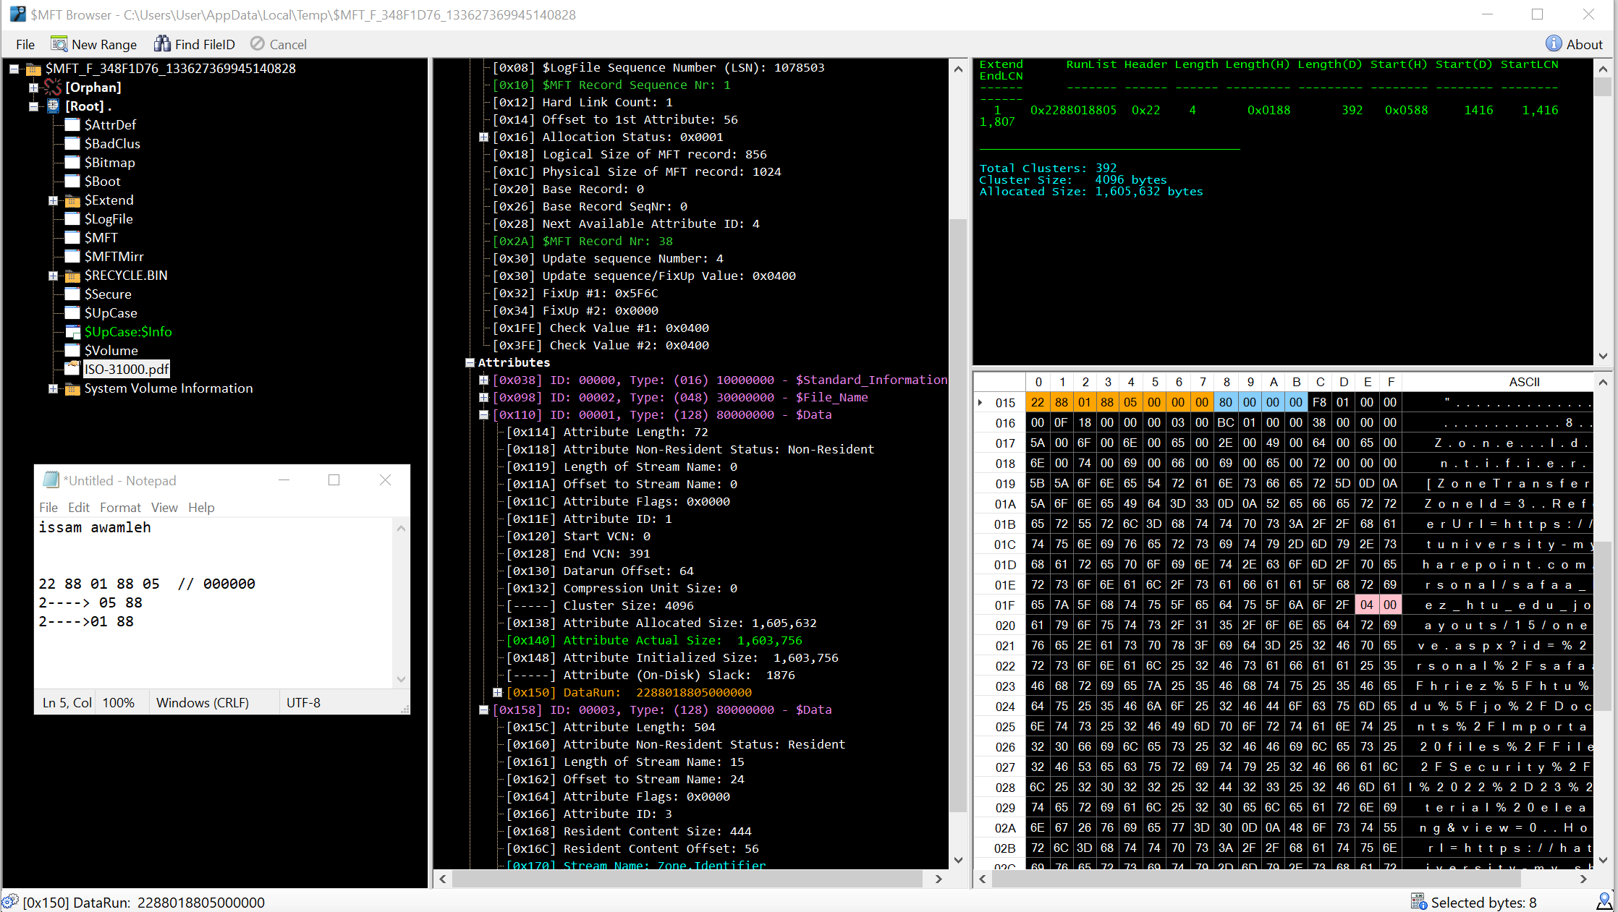

4_ after we got the number we can calculate it:

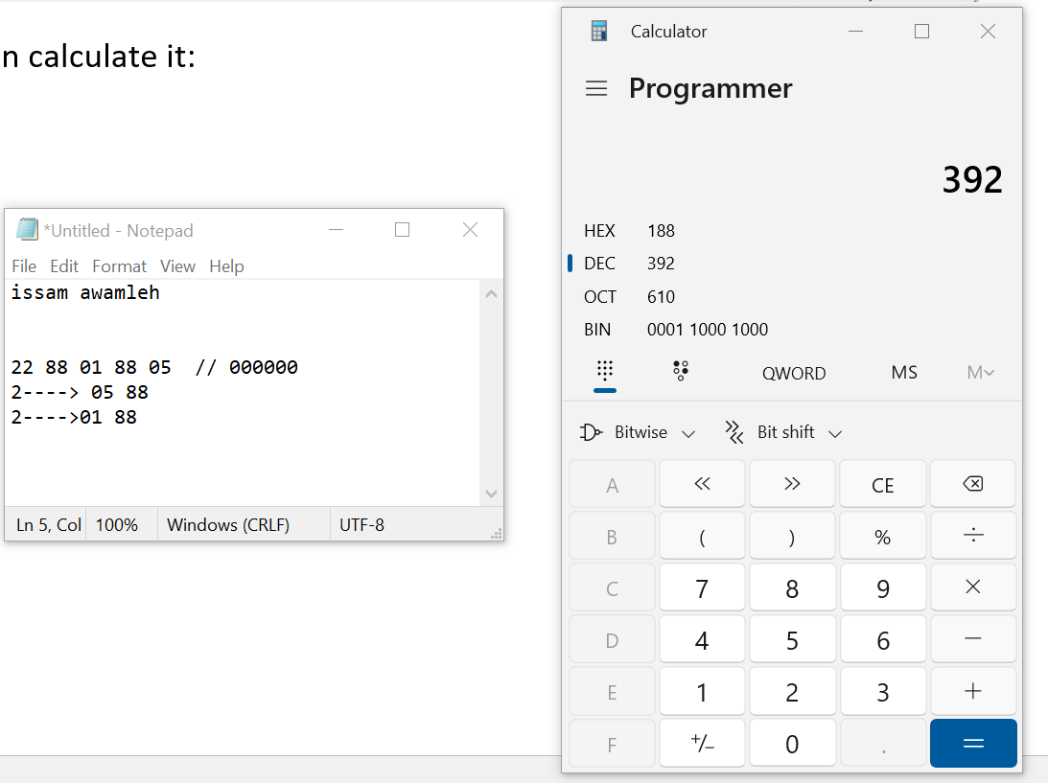

THE ANSWER IS : 392 clusters